NAME:G.SAI SAHITH | REG NO:192424179

EX.NO-5: LIBRARY BOOK MANAGEMENT SYSTEM
AIM:
To develop a cloud-based Product Selling System using Zoho Creator for managing product sales, billing, and discounts, and to demonstrate the Software as a Service (SaaS) cloud computing model.

PROCEDURE:
- Log in to the Zoho Creator cloud platform using a valid account.
- Create a new application named Product Selling System.
- Design a form to store customer and product details.
- Add fields such as Customer Name, Customer Phone, Product Name, Category, Quantity, Price, Total Amount, Order Date, Payment Method, Order Status, Discount (%), Discount Amount, and Final Bill.
- Configure drop-down values for Product Name, Category, Payment Method, and Order Status.
- Create a workflow to calculate the Total Amount based on Quantity and Price.
- Apply discount rules according to the total purchase amount and calculate the Discount Amount and Final Bill automatically.
- Update the Order Status automatically after successful order submission.
- Create a report to display all product sales and billing details.
- Test the application by entering sample data and verify that the bill and discount are calculated correctly.
CODE:
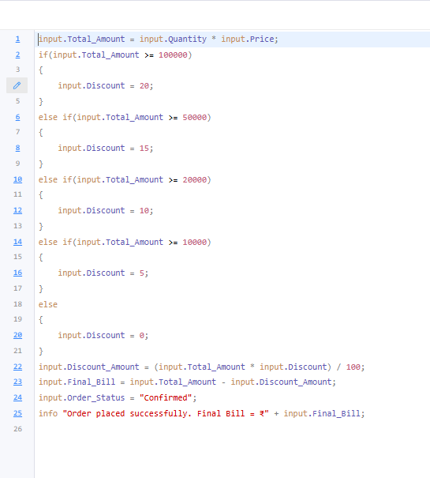

OUTPUT:
PRODUCT SELLING SYSTEM
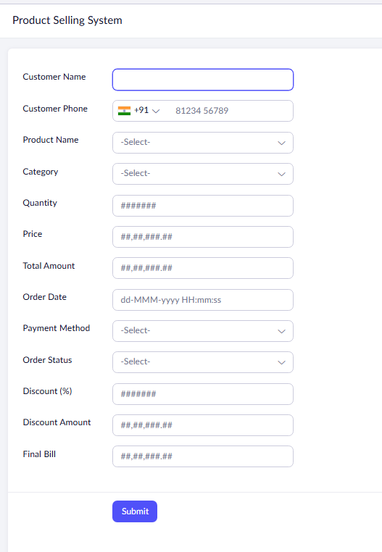

REPORT:

RESULT:
The Product Selling System was successfully developed using Zoho Creator. The application automatically calculates the total amount, discount, and final bill, demonstrating the Software as a Service (SaaS) model through cloud-based access and data management.

